Complete these sentences with a present simple or a present continuous
- Every Monday, Sally….. ……………………………. her kids to football practice. (to drive)
- Shhhhh! Be quiet! John …………..………………………………………(to sleep)
- …………………………………. the gym every Thursday? (to go/you)
- Don't forget to take your umbrella. It (rain) …………………………………………..
- I'm sorry I can't hear what you (say) ………………………… because everybody (talk)………………………………… so loudly.
- The sun (to be) ………………………………………………………………yellow.
- I ………………………………………. basketball right now, I ……………………….. a placement test for English. (to play/not) (to take)
- Justin (write, currently) …………………………………………… a book about his adventures in Tibet. I hope he can find a good publisher when he has finished it.
- ……………………………….. a book right now? Is it a good one? (to read/ you)
- This delicious chocolate …………………………….. from Switzerland. It is made in Belgium (to be/not)
Complete this letter from Sara with a present simple or present continuous
verbs: to have, to work/not, to write, to be, to go
Dear Mary
How are you? I received your letter last week. Thank you for the recipe for the cake I asked for. I made it last week and it was very nice. Let me tell you something about myself. I ………………….. a new job in a supermarket in the city centre. I …………… there every day at 3 o'clock in the afternoon and work there till 10 o'clock in the evening. Right now, I ………………………………. because I ………………………….. this letter. Don’t tell my boss! I got my first wages (=loon) last week and I went shopping immediately! I bought a new stereo for my bedroom. It ……………………. gold and black. How are you holding up? Please write to me soon with all your news.
All the best
Sara.
Circle the correct present tense (simple present or present continuous).

- My older sister is (often) listening / (often) listens to pop music.
- Our teacher is giving / gives us a test every month.
- Mr. Michael usually is growing / grows roses in his garden.
- They are building / build a new house on the hill now.
- Maria is drinking / drinks milk every morning.
- Look! Nick is running / runs down the hill.
You are going to interview Radja Nainggolan. You expect to get these answers. Complete your set of questions. (use question words)
Example: Who are you? I am Radja Nainggolan.
………………………………….? I love my girlfriend.
How much……………….………..? I get €15000 per match.
…………………………………....? I go to bed at 22 o’clock.
…………………………….………? I am wearing a black suit.
…….………………………………? I am playing with a dog.

What are these people doing? Choose 4 people in this picture and write a sentence about him/her.
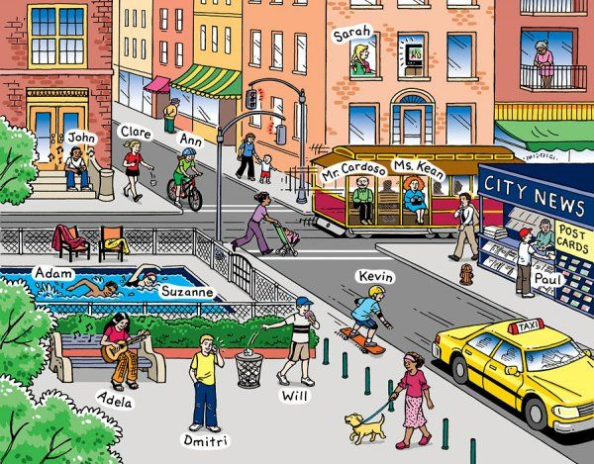

Example: Adam and Suzanne are swimming in the swimming pool.
- Andela …………………………………………………… the guitar.
- ………………………………………………………………………………………………
- ………………………………………………………………………………………………
- ………………………………………………………………………………………………

Your new teacher of English is very curious and asks you a lot of questions. Answer the questions your teachers asks you.
How often do you walk to school?
…………………………………………………………………………………………

What do you do after school?
……………………………………………………………………………………………

What are you doing?
………………………………………………………………………………………………

Where does your mother/father work?
……………………………………………………………………………………………….

What is the teacher doing now?
………………………………………………………………………………………………..
Complete this letter from Sara with a present simple or present continuous
Dear Mary
How are you? I received your letter last week. Thank you for the recipe for the cake I asked for. I made it last week and it was very nice. Let me tell you something about myself. I ………………….. (have) a new job in a supermarket in the city centre. I …………………… (to go) there every day at 3 o'clock in the afternoon and work there till 10 o'clock in the evening. Right now, I ……………………………….(to work/not) because I ………………………….. (to write) this letter. Don’t tell my boss! I got my first wages (=loon) last week and I went shopping immediately! I bought a new stereo for my bedroom. It ……………………. (to be) gold and black. How are you holding up? Please write to me soon with all your news.
All the best
Sara.
Circle the correct present tense (simple present or present continuous). Pay attention to words that can help you.

- My older sister is often listening / often listens to pop music.
- Our teacher is giving / gives us a test every month.
- Mr. Michael usually is growing / grows roses in his garden.
- They are building / build a new house on the hill now.
- Maria is drinking / drinks milk every morning.
- Look! Nick is running / runs down the hill.

You are going to interview Radja Nainggolan. You expect to get these answers. Complete your set of questions. (Use your card when you need to.)

Example: Who are you? I am Radja Nainggolan.
Who……………………………? I love my girlfriend.
How much……………………..? I get €15000 per match.
When…………………………....? I go to bed at 22 o’clock.
What…………………….………? I am wearing a black suit.
What………………………………? I am playing with a dog.
What are these people doing? Take a look at the sentences and complete the sentence.
these verbs can help you (to play; to walk; to skateboard; to buy; to cycle; to listen; to throw; to swim; to ride; to talk)

- Andela ………………………………….. the guitar.

- Adam and Suzanne …………............................................ in the pool.

- Dimitri …………………………………... on the phone with his mother.

- Paul ……………………………………….. a postcard to send to his grandparents.

Introduce yourself and introduce the person sitting next to you.

Example: I am Sofie Buyens and I am 22 years old.
I live in Herentals and I have 1 brother.
………………………………………….
(talk about your hobbies, your favourite subject at school, your pet, ….)

………………………………………………………………………………………………………………………………………………………………………………………………………………………………………………………………………………………………………………………………………………………………………………………………………………………………………………………………………………………………………………………………………………………………………………………………………………

